***Day 6 - Deployment Preparation and***

***Staging and Environment Setup***

***Deployment Details:***

***1. Choose a Hosting Platform***

***We will use Vercel for deploying the application due to its seamless integration with***

***Next.js and ease of use***

***Deployment Link :***[***https://hackathon-3-hekto-aa.vercel.app/***](https://hackathon-3-hekto-aa.vercel.app/)

***Repository Link :*** [***https://github.com/mohsin-ali08/Q2-Final-Hackathon-GIAIC***](https://github.com/mohsin-ali08/Q2-Final-Hackathon-GIAIC%20)

# Step 1: Hosting Platform Setup

## 1. Choose a Hosting Platform

***We will use Vercel for deploying the application due to its seamless integration with Next.js and ease of use.***

## 2. Link Your GitHub Repository

1. ***Log in to your Vercel account (or create one if you don’t have an account).***
2. ***Click on the "Add New..." button and select "Project".***
3. ***Import your GitHub repository:***

***○ Authorize Vercel to access your GitHub account if prompted. ○ Select the repository you want to deploy.***

*By MOHSIN ALI*

# Step2 : Configure Environment Variables

## 1. Add Environment Variables in Vercel

1. ***Go to your Vercel project dashboard.***
2. ***Navigate to "Settings" > "Environment Variables".***
3. ***Add the necessary environment variables one by one:***

***4.***

***○ For example:***

***NEXT_PUBLIC_SANITY_PROJECT_ID=your_project_id***

***NEXT_PUBLIC_SANITY_DATASET=production***

***API_BASE_URL=https://api.example.com***

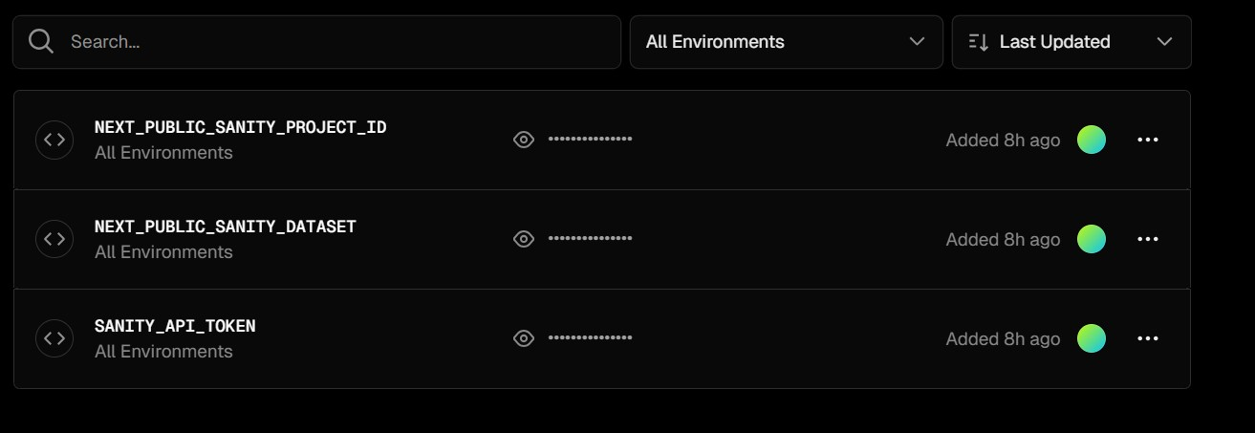

*By MOHSIN ALI*

## 3. Test Staging Deployment

1. ***Deploy the staging branch to the staging environment.***
2. ***Perform all required testing (functional, performance, and responsiveness).***
3. ***If successful, promote changes to the production environment by merging the staging branch into main.***

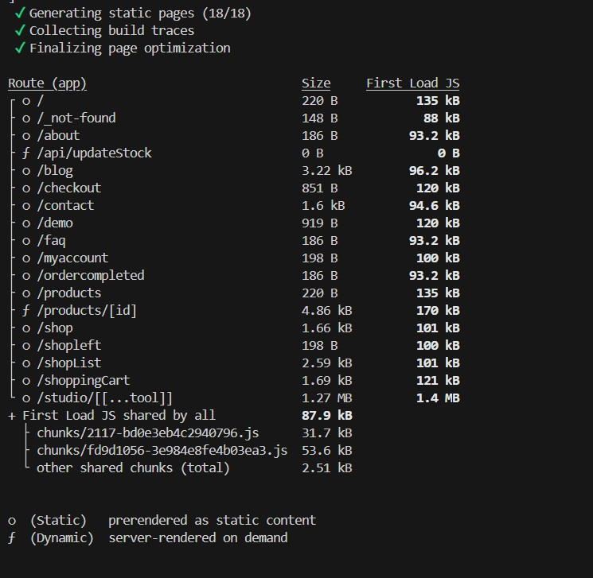

*By MOHSIN ALI*

***Performance Checking****:*

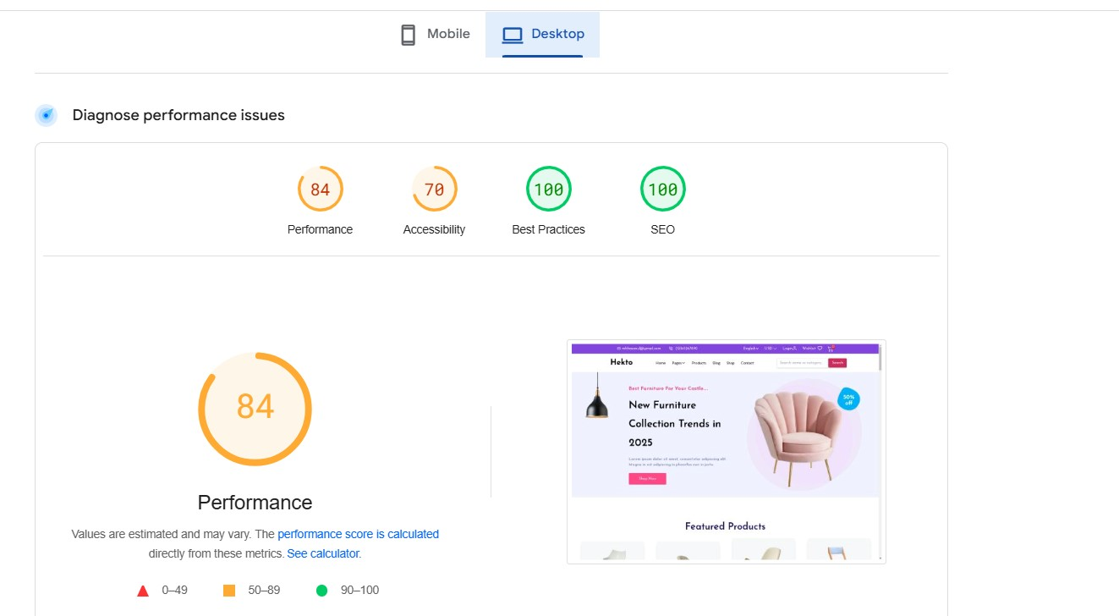

*By MOHSIN ALI*